

**Reference Letter**

I would like to recommend M.Rahul Raj as a high school Mathematics Teacher. As the head of Mathematics Department, I am quite familiar with Rahul’s teaching techniques and skills and I am confident he is the right person to teach high school mathematics. Right now Rahul is teaching Algebra II and Honors Trigonometry. As a staff member, Mr.Rahul was pleasant and cooperative. He has a delightful sense of humour and contributed much to the staff, both professionally and socially.

It has been my pleasure to have worked with Ms. Rahul. He is a hardworking, well-organized, committed teacher who has given much to our learners. He enjoys the respect of his learners, their parents, her fellow teachers, and the school administration.

I am pleased to recommend him without reservation, for any position requiring hard work, initiative, loyalty, and dedication. Please contact me if you need any further information rakeshclassic95@gmail.com

Telephone (+91) 8686818100

Sincerely,

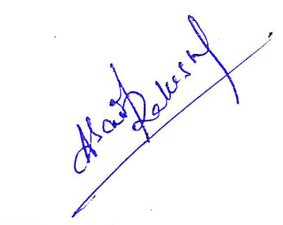

ANUGULA SAI RAKESH

Head of Department (Mathematics)